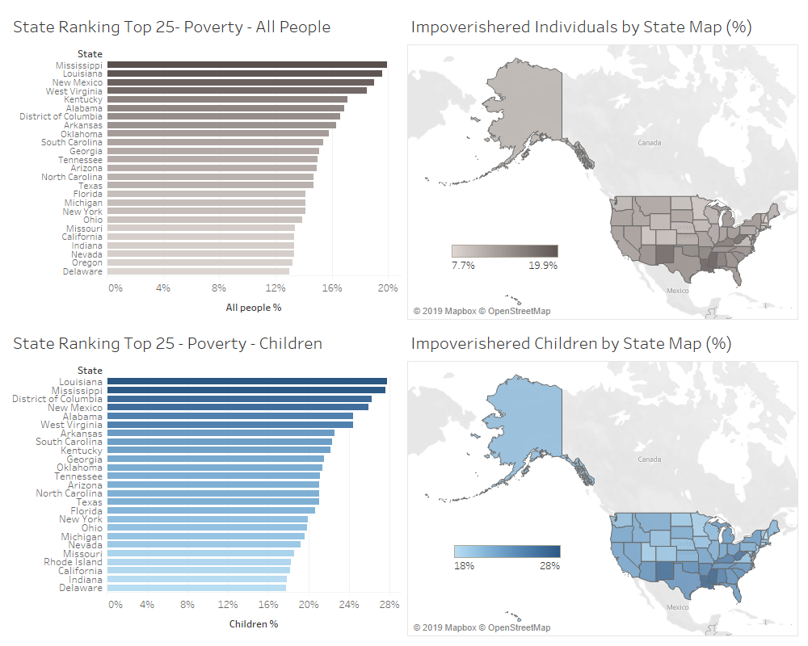An Analysis of Crime and Poverty in the United States (2017)

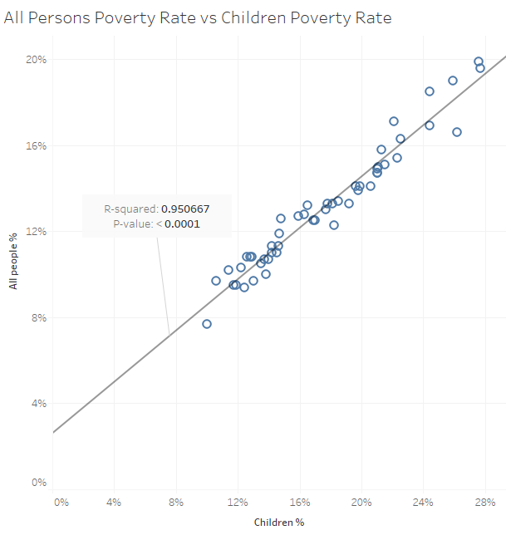 State levels of poverty for total population and children are very similar. When comparing the two rates, there is a very strong positive correlation. There are many factors in play, but one conclusion may be that impoverished children do not find much success getting out of the poor financial situations they grew up in. There are mostly southern states that rank highly in terms of poverty rate.

The charts generated for analyzing poverty rates in the US are easily interpreted by the viewer. I wanted to provide this data first, so that the viewer gains an understanding of poverty in the US before proceeding to view the relationships between various crimes and poverty. Poverty data for all people and for children have different color schemes for quick contrast. The maps are an effective way to quickly highlight which states stand out among the rest. For more clarity on State rankings, the bar charts are provided with the same shading scheme. The scatter plot with trend line is provided as a clear visualization of the strong positive correlation between total population poverty rates and children poverty rates. An annotation is included so that the viewer can see the actual statistical relationship.

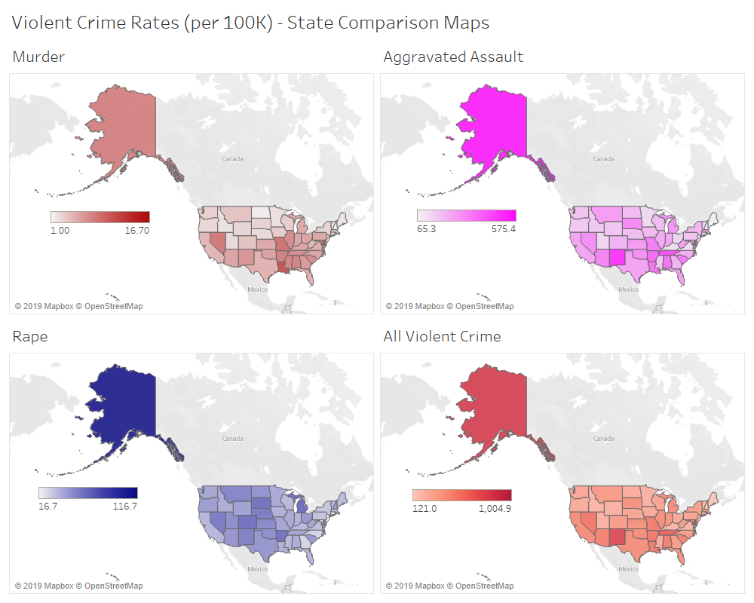

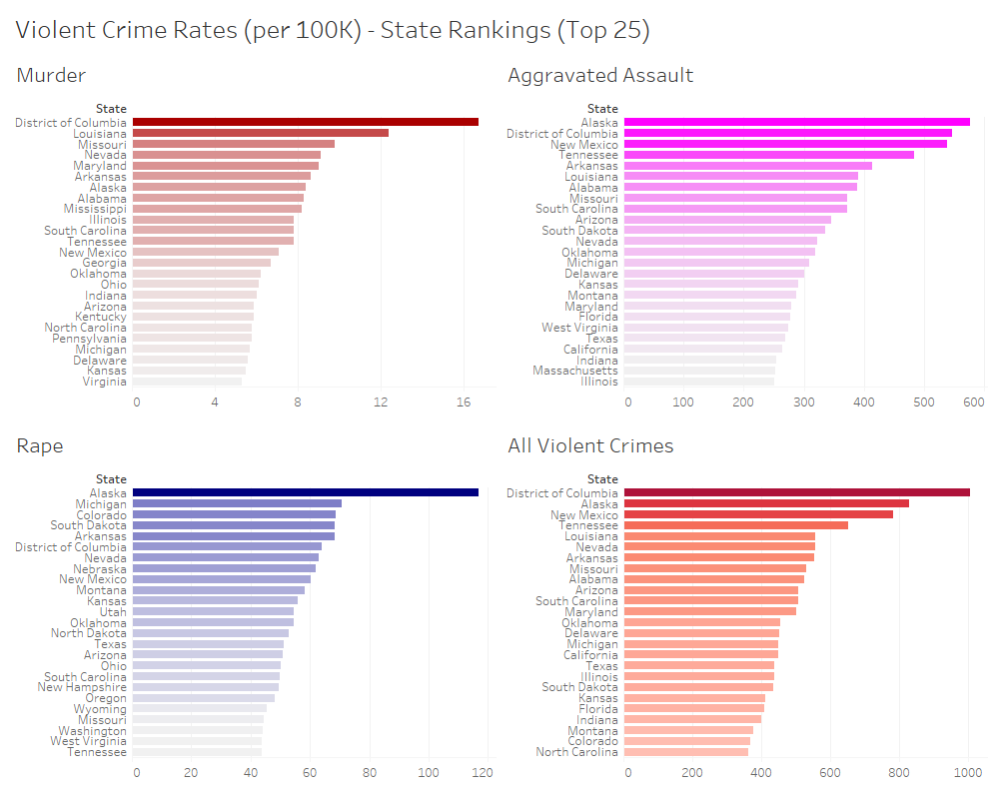

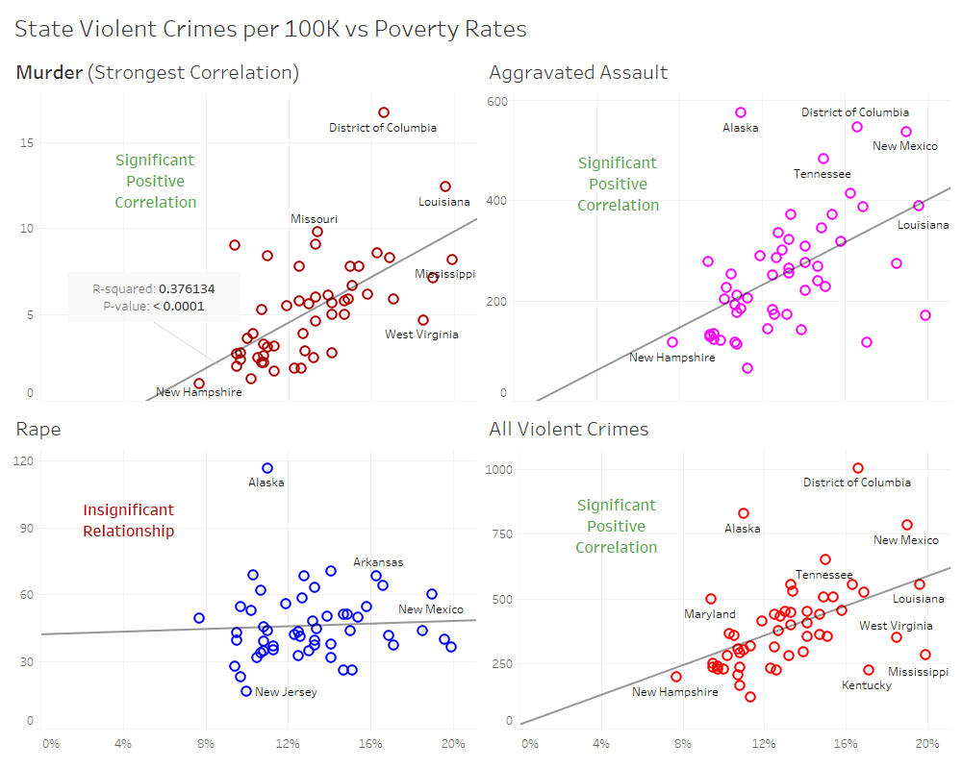

Alaska and DC stand out for each type of violent crime. Alaska, however, does not rank highly compared to other states in terms of poverty. Of the different types of violent crime looked at in this study, State murder, aggravated assault, and total violent crime rates have a significant positive correlation with State poverty rates with a p value < 0.05. With this being said, the linear regression lines do not result in very strong fits with the data. Of the violent crimes, murder has the best fit with an R-squared of 0.376. Rape does not have a significant correlation with poverty.

I used maps again for the violent crime rate data for the same reason as previously stated. It is a quick and effective way to illustrate State comparisons. The bar charts are included to clarify where States rank among each violent crime. For example, DC is hard to view in the maps, but is pertinent to the analysis. The main objective of the scatterplots for each crime is to point out which of the crimes have a relationship with poverty. The annotation in green/red bold make it easy for the viewer to understand the narrative or storyline. The annotation with statistical information is provided for the murder scatter plot because it has the strongest correlation. Labels for States may not have been entirely necessary, but are provided, mainly for the viewer’s curiosity, and also to see similarities among some of the plots. The color choices are the same between maps, bars, and scatter plots to avoid any confusion and eyestrain.

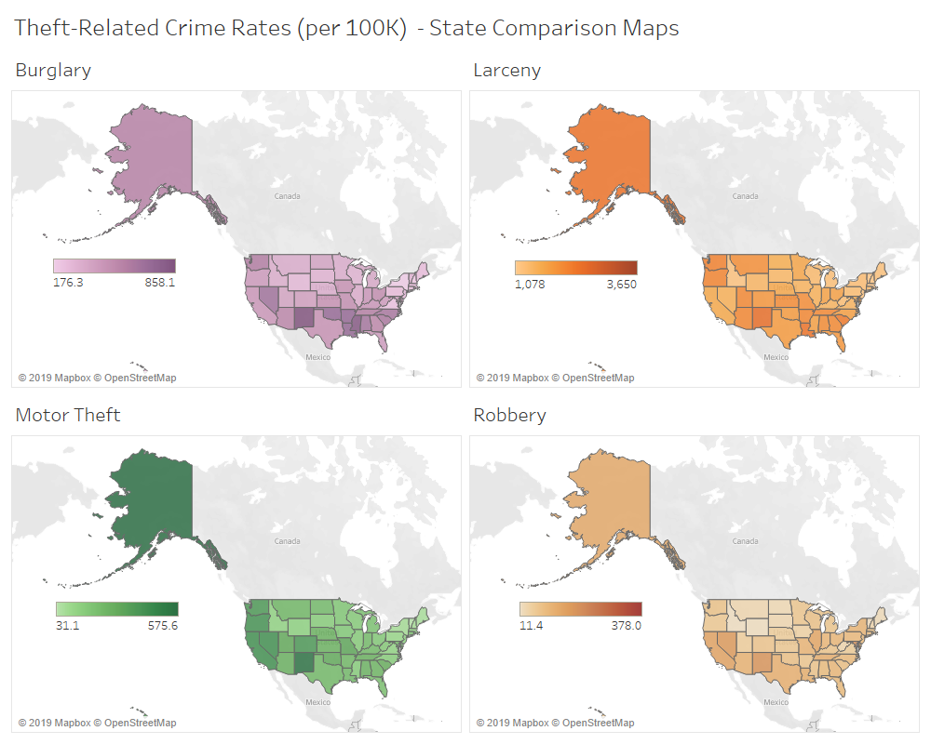

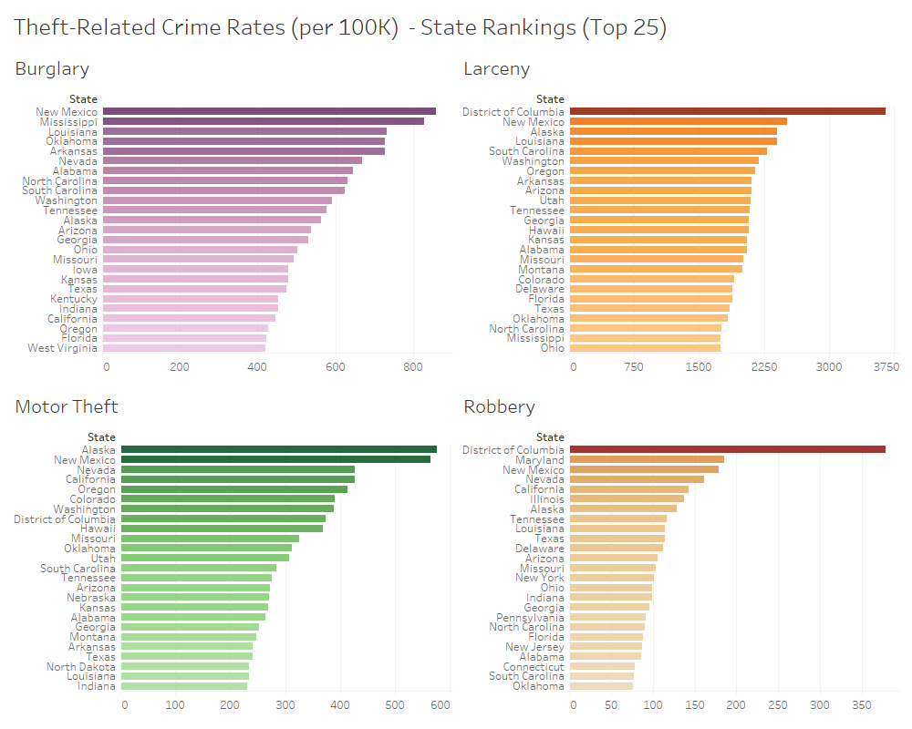

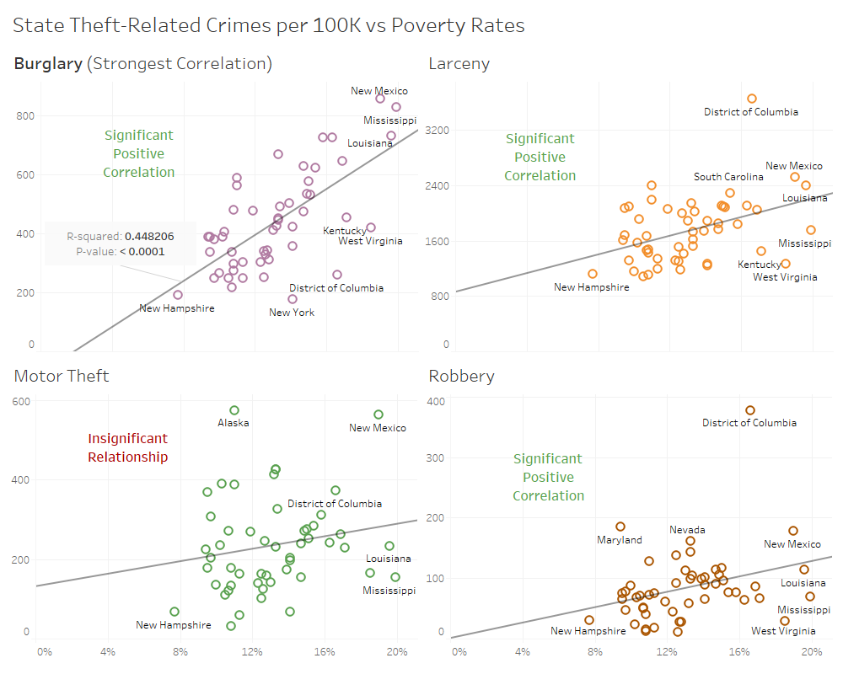

In addition to violent crimes, theft-related crimes are also analyzed. New Mexico ranks in the top 3 in every theft-related crime. With the exception of burglary, DC ranks highly for theft-related crimes in addition to violent crimes. Burglary, larceny, and robbery all have a significant positive correlation with poverty with p-values < 0.05. Burglary has the strongest correlation of any crime, but still does not have a very strong line of best fit with an R-squared value of 0.488. Motor theft did not have a significant correlation with poverty.

The same logic was used for the theft-related crime visualizations as for the violent crime visualizations. This allows for comparison between the two crime categories. An important note is that the storyline portrayed here is mainly dealing with the big picture, but the District of Columbia, in particular, is an outlier in most of the crime categories analyzed and seems to have the strongest relationship between almost every crime and poverty. This could be a case study in and of itself.

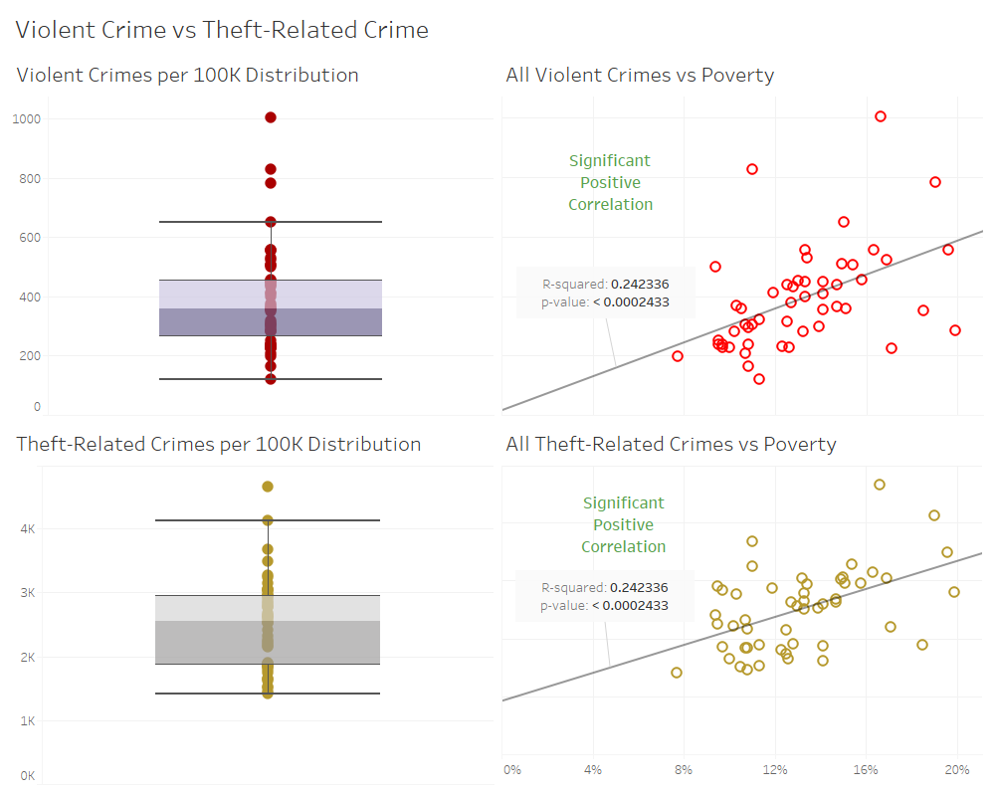

The distribution of all violent crime rates and theft-related crime rates is mostly similar. There is slightly more variation for theft-related crimes and higher occurrences in each state. The distribution for violent crimes is more compact, with the exception of a few outliers. Both crime categories have a slight, but significant positive correlation and have very similar R-squared values.

These last visualizations provide a summary of comparison between violent crime and theft-related crime. I felt this was necessary because the because the previous visualizations (maps, bars, and scatters) are mostly included to drill down on each violent crime and theft-related crime, respectively. The last set of visualizations are a much quicker and less overwhelming means to compare the larger categories of violent crime and theft-related crime.

**Data sources and un-used visualizations**

It took some thorough research and digging to fall on the data that I ended up using. I stumbled upon a similar FBI data table on crime statistics early on and got the idea to link poverty and crime statistics. I wanted recent data and, knowing how unions work within Tableau, I knew I needed the right type of worksheets that could form a clear union between each other. It took a while to find a workable US poverty data source by State and that was the same year as the crime statistics data. I had to clean up the formatting for both datasets to allow for inner joining in Tableau. I was able to successfully inner join by State and proceed with the analysis.

I did not include the population map, poverty rate box plots, and correlation charts between any crimes and child poverty. These visualizations were not pertinent to the storyline I decided on. The story focused in on the connection between total population poverty and various types of crimes.

*Data was obtained from USDA and FBI public data tables*

<https://data.ers.usda.gov/reports.aspx?ID=17826>

<https://ucr.fbi.gov/crime-in-the-u.s/2017/crime-in-the-u.s.-2017/topic-pages/tables/table-4>